EXPERIMENT-5-Student Record SaaS App

Aim:
To create a cloud-based student record management system.
Procedure:
- Created a Student form to store details like name, department, and marks.
- Records were added and managed using Zoho Creator.
- Reports were used to display student data in tabular format.
Output:
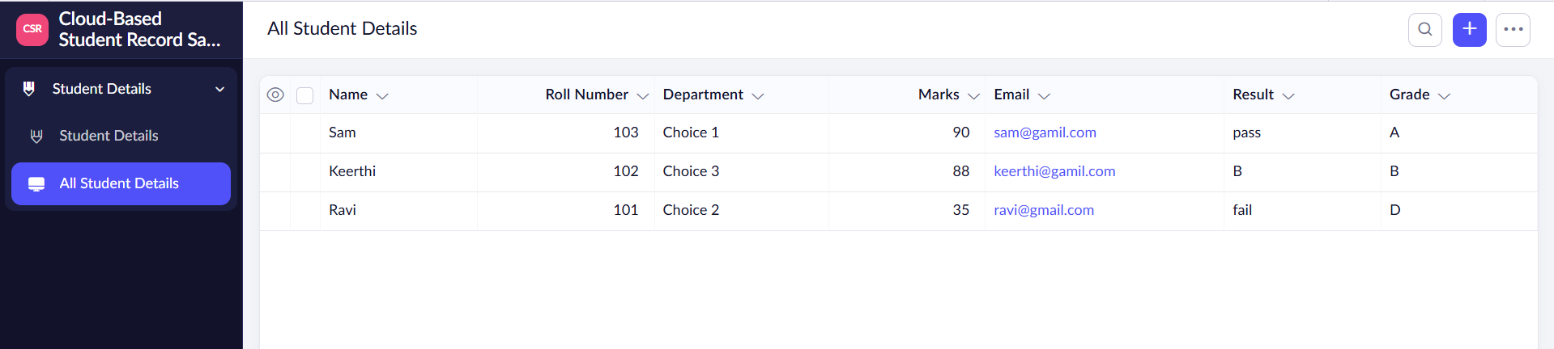
Result:
Student records are stored and accessed easily through the cloud.

